|  |  |
| --- | --- |
| **R5 Large Lot Residential land (Wentworth LGA)** | |
| Total number of lots | **302** |
| Total number of lots (including proposed lots) | **352** |
| Total area of R5 Land within LGA | **4,165,609m2 or 4,165km2** |
| Percentage of LGA zoned as R5 | **0.015%** |

|  |  |  |  |  |  |
| --- | --- | --- | --- | --- | --- |
| Locality | Number of lots within parcel | New Lots proposed: | Maximum lot bearing capacity | Total Area (m2) | GPS Coordinates |
| Gol Gol | 228 lots | 46 | 380 (approx.) | 1874200 | -34.181840, 142.233255 |
| Gol Gol | 5 lots | 0 | 55 - 60 (approx.) | 352348 | -34.163576, 142.228184 |

|  |  |  |  |  |  |
| --- | --- | --- | --- | --- | --- |
| Locality | Lot parcel containing: | New Lots proposed: | Maximum lot bearing capacity | Total Area (m2) | GPS Coordinates |
| Mourquong | 8 lots | 0 | 14 (approx.) | 87291 | -34.128436, 142.076833 |
| Mourquong | 7 lots | 0 | 17 (approx.) | 90495 | -34.148360, 142.159424 |
| Mourquong | 1 lot | 4 | 20 (approx.) | 116603 | -34.147367, 142.120005 |

|  |  |  |  |  |  |
| --- | --- | --- | --- | --- | --- |
| Locality | Lot parcel containing: | New Lots proposed: | Maximum lot bearing capacity | Total Area (m2) | GPS Coordinates |
| Dareton | 14 lots | 0 | 44 (approx.) | 313731 | -34.101899, 142.047491 |
| Dareton | 1 lot | 0 | 3 – 4 (approx.) | 17998 | -34.096292, 142.047476 |

|  |  |  |  |  |  |
| --- | --- | --- | --- | --- | --- |
| Locality | Lot parcel containing: | New Lots proposed: | Maximum lot bearing capacity | Total Area (m2) | GPS Coordinates |
| Trentham Cliffs | 4 lots | 0 | 29 (approx.) | 174702 | -34.224178, 142.246836 |

|  |  |  |  |  |  |
| --- | --- | --- | --- | --- | --- |
| Locality | Lot parcel containing: | New Lots proposed: | Maximum lot bearing capacity | Total Area (m2) | GPS Coordinates |
| Wentworth | 23 lots | 0 | 23 (approx.) | 199506 | -34.082373, 141.924869 |

|  |  |  |  |  |  |
| --- | --- | --- | --- | --- | --- |
| Locality | Lot parcel containing: | New Lots proposed: | Maximum lot bearing capacity | Total Area (m2) | GPS Coordinates |
| Curlwaa | 11 lots | 0 | 148 (approx.) | 938735 | -34.120081, 141.960103 |

|  |  |  |  |  |  |
| --- | --- | --- | --- | --- | --- |
| **Totals** | | | | | |
| Locality | Total lot parcels | Total new lots proposed: | Maximum lot bearing capacity | Total Area (m2) | GPS Coordinates |
| All localities | 302 lots | 50 | 733 (approx.) | 4,165,609m2 | N/A |

***Figure 1.1:*** Distribution of R5 Large Lot Residential land within Wentworth LGA

|  |
| --- |
| **R5 land within Wentworth LGA** |

It is estimated that there are 302 R5 Large Lot Residential lots of land within the Wentworth local government area itself.

Having said this, the maximum lot bearing capacity for all R5 Large Lot Residential land within the LGA is somewhere around 733 – this takes into account all of the required infrastructure, road reserves, streets, nature strips, etc that would realistically be required to service these lots of land appropriately.

The total area of R5 Large Lot Residential zoned land within the Wentworth LGA is approximately 4,165km2 which when compared to the LGA’s total area of 26,273,733km2 is quite an insignificant number.

***Figure 1.2:*** Percentage of R5 zoned land within Wentworth LEP

The amount of R5 Large Lot Residential land within the Wentworth LGA in comparison to other zoned land here is shown above in *Figure 1.2*.

|  |
| --- |
| **How much R5 land does Buronga Gol Gol have?** |

Within the actual Buronga Gol Gol catchment area itself, there is somewhere around 25,911,359m2 of R5 Large Lot Residential zoned land, which equates to around 15% of the Buronga Gol Gol Catchment Area itself.

The below figure (Figure 1.3) attempts to visually represent the amount of R5 land within Buronga Gol Gol as a Catchment Area.

***Figure 1.3:*** Percentage of R5 Large Lot Residential land within the Buronga Gol Gol Catchment area

|  |
| --- |
| **Loss of previous R5 Large Lot Residential land** |

Within recent years, Gol Gol has seen some of its land being rezoned from R5 to SP1 (Special Activities). This has subsequently resulted in the loss of 144,216m2 of R5 Large Lot land from Gol Gol (See Figure 1.4). We propose that additional R5 land (of a similar size in nature) could be sourced from the northeast quadrant of Wilga Road, Gol Gol (See Figure 1.4). This land is currently zoned as RU1 Primary Production. See the below Figure 1.4.

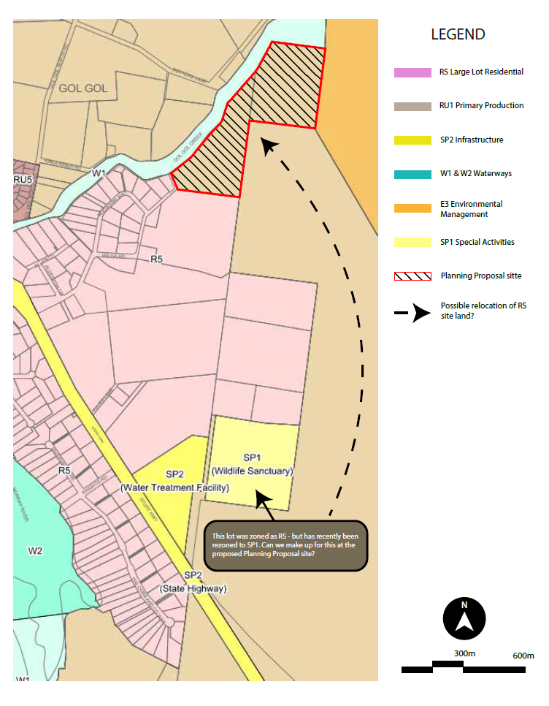

***Figure 1.4:*** Map showing the possible redistribution of R5 Large Lot Residential land.

|  |
| --- |
| **Conclusion** |

We are under the impression that there are actually only 302 existing R5 Large Lot Residential lots of land within the Wentworth LGA with a total combined area of around 4,165,609m2. In addition to the already existing R5 Large Lot Residential lots of land, there are subdivisions granted which would put forward some 47 new R5 lots of land. These new subdivisions do not yet appear on LEP maps, or council’s IntraMaps system.

As it currently stands with the minimum lot size requirement of 5,000m2, and taking into account public infrastructure and road reserve requirements etc, we calculate that 733 R5 Large Lot Residential lots of land are possible.

We have determined that the estimate of “2000+ Lots” quoted back in 2014 was actually including by both R5 Large Lot Residential and RU5 Village zones.

Unless our calculations are incorrect, we can only see 302 existing R5 Large Lot Residential lots with a total area of around 4,165,609m2 or 4,165km2.